39 Gordon Street, Huntly, Aberdeenshire AB54 8EQ

Telephone: 01466 792627 Fax: 01466 794962

VETERINARY SURGEONS
STRATHBOGIE VETERINARY CENTRE LTD

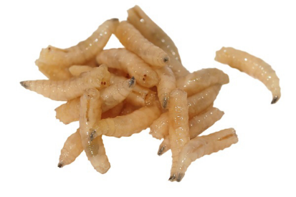As much as we continue to enjoy the warmer weather and long nights, as do many parasites – especially female blowflies. The threat at this time of year of maggots on stock is pretty high and can be fatal as animals can go into toxic shock. Mucky bums and long tails all entice the female flies (though they aren’t very fussy!) to lay their eggs in the fleece which in these warm conditions rapidly hatch to maggots which then start to eat the poor sheep alive! Ideally, pour ons or dipping should be used to prevent strike from occurring, however due to shearing times and withdrawal periods this may not always be possible. Treatment should be prompt and supportive care should also be given, ensuring they are eating and drinking, and antibiotic cover and painkiller if required.
Whilst on the topic of parasites a quick reminder that naïve, the unvaccinated and young cattle are susceptible to lungworm infection over the coming months. Lungworm can be treated with any of the classes of wormer. Lungworm affects both cattle and sheep – though these worms are species specific – ie. Dictylcaulus viviparus infecting cattle shouldn’t cause issues with sheep and vice versa. Clinical signs to keep an eye out for are; coughing, nasal discharge, increased respiratory rate and effort and even worms coming out of their noses! Faeces samples can be sent to the lab to confirm the presence of larvae in faeces.
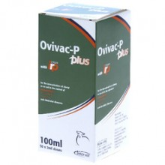Over the last month or so we have seen several cases of Pasteurella pneumonias affecting growing lambs. This often presents as a sudden death, as well as coughing, nasal discharge, falling behind the rest of the group, recumbency and increased respiratory rate and effort. Mannheimia haemolytica is the bacteria which causes this type of pneumonia, and as seen can not only be fatal, but reduces daily live weight gain, increases susceptibility to other diseases, and increases time til slaughter. Vaccinating lambs with Ovivac P Plus not only covers them against other often fatal clostridial diseases such as; pulpy kidney, braxy, blacks disease, and blackleg but also reduces deaths from Pasteurella. Antibodies only last for a couple of weeks if the mothers have been vaccinated, so lambs can be vaccinated from 3 weeks of age. The primary vaccination course consists of 2 injections 4-6 weeks apart.
With this years lambing well over and done with for this year, soon the cycle will be starting again. The search for the right sire(s) for next year’s lambs will be underway. Following last months newsletter, many of you expressed an interest in ram semen testing. We have purchased a ram ejaculator and will be doing the semen testing at an introductory price – please ring for more information and numbers of tups to be tested. It is a good opportunity for us to check out your rams prior to the breeding season, and remove those rams who are firing blanks! We are still doing Bull semen testing for the special price of £50 per bull. Please phone to book a visit!
A quick reminder for those vaccinating for BVD…. Animals should be vaccinated prior to going in with the bull. Primary vaccination of heifers with BOVILIS can be done from 8 months of age – 2 doses, 4 weeks apart. The second vaccination must be NO LATER than 4 weeks before being put in with the bull. BOVELA is a single dose vaccination – both for heifers (not vaccinated before) and the cows booster shot. Please note that if using bovela in heifers, the bovela vaccine must also be used in subsequent years to boost.

