The BVD eradication scheme has been ongoing for a few years now. So this is a note to explain where we are with it now. By January 2017, the scheme had identified 4387 PI animals. And as of January 2017 there were 410 PIs alive on 167 holdings in Scotland, of which, 27 PIs were in Aberdeenshire. At that point 89.6% of breeding holdings had a negative BVD status. We are getting there, but there is still a way to go.
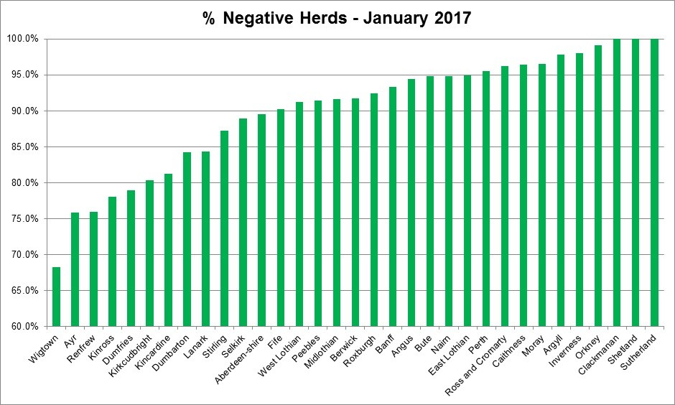http://www.gov.scot/Topics/farmingrural/Agriculture/animal-welfare/Diseases/disease/bvd/whatsnew, http://www.nationalarchives.gov.uk/doc/open-government-licence/version/3/

From April 2017 a new herd status was created, so that herds will now be registered as BVD positive where there is evidence that there is a live PI animal in the herd. Once the PI has been removed from the holding, or the animal has been re-tested (allowing the presence of the PI to be ruled out), the BVD herd status will return to not-negative. It usually takes a year for herds that have had a PI to then get a negative status as the whole breeding herd needs to have had calves again. The ‘not negative’ status will still include animals where evidence of active infection has been found but no actual PI.
This will highlight herds that are a higher risk for those purchasing or moving cattle, as identifying and removing PIs is the most important part of the eradication scheme. Remember you can all check your BVD status on the ScotEID website at www.scoteid.com/lookup. You can also do this when buying animals, however you need a UK number and/or holding number.

